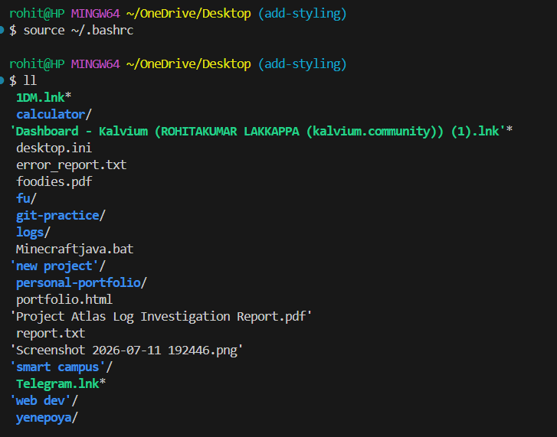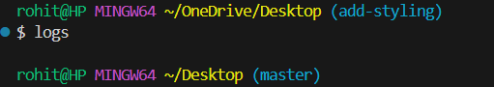
An alias in Linux is a user-defined shortcut for a longer or more complex terminal command. When developers configure custom aliases in their .bashrc file, they streamline repetitive tasks, reduce typing errors, and save time during daily navigation and git operations. Saving these aliases in the .bashrc configuration file ensures that the customized environment persists across all terminal sessions. Running source ~/.bashrc reloads the configuration immediately so that your newly created short commands can be executed in the current session.

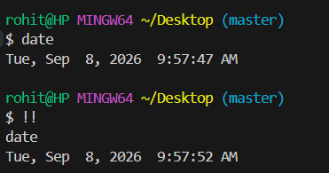
Terminal efficiency relies heavily on built-in productivity features like command history, reverse search, and auto-completion. The history command displays a chronological log of previously executed commands, while shortcuts like !! quickly re-run the most recent command without retyping it. Additionally, Ctrl + R activates reverse search, allowing you to search through past commands by typing a few matching characters, and the Tab key automatically completes file paths and directory names, reducing typing effort and preventing syntax mistakes.
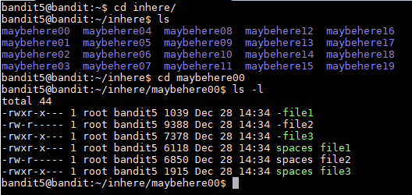
Levels 3 to 4: Level 3 focuses on finding hidden files, which start with a period (.) and remain unlisted under standard directory commands; using ls -a exposes all files within the directory. Level 4 involves searching through multiple files to identify human-readable content, which is achieved by using the file command to check each file's data type before inspecting its contents with cat
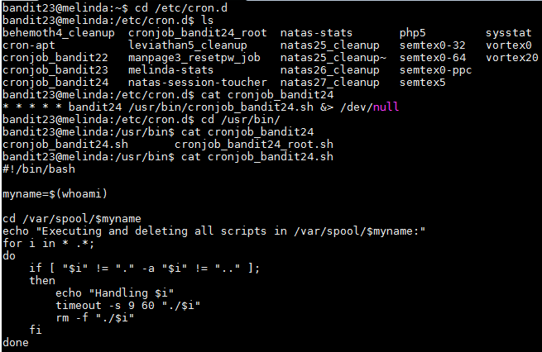
Level 5: Level 5 demonstrates searching for specific files based on criteria like file type, size, and permissions. The find command is used with flags such as -type f (regular file), -size 1033c (exact byte count), and ! -executable (non-executable file) to isolate the single matching file among many directories.

